 **Mahavir Education Trust's**

**Shah & Anchor Kutchhi Engineering College,**

**Chembur, Mumbai 400 088**

**UG Program in Information Technology**

**Name:** GARIMA MAHENDRA MAHTO

**Class-Batch:** BE_5A

**Roll No:** 07

| **EXPERIMENT_NO.03** | | | | | |
| --- | --- | --- | --- | --- | --- |
| **Date of Performance:** | 16/09/2021 | | | | |
| **Date of Submission:** | 23/09/2021 | | | | |
| **Program formation/ Execution/ ethical practices (07)** | **Documentation (02)** | **Timely Submission (03)** | **Viva Answer (03)** | **Experiment Marks (15)** | **Teacher Signature with date** |
|  |  |  |  |  |  |

**EXPERIMENT_NO.03**

**AIM:** Mini Project: Construction of a domain specific Chatbot using Natural Language Processing techniques.

**LAB OUTCOME:** 7. ITL603.6 Apply concept Natural Language processing and cognitive computing for creation of domain specific Chatbots.

# THEORY:

* **Natural Language Processing:**

Natural Language Processing (NLP) refers to AI method of communicating with intelligent systems using a natural language such as English.

Processing of Natural Language is required when you want an intelligent system like robot to perform as per your instructions, when you want to hear decision from a dialogue based clinical expert system, etc.

The field of NLP involves making computers to perform useful tasks with the natural language’s humans use. The input and output of an NLP system can be −

* + Speech
  + Written Text

# Components of NLP

There are two components of NLP as given −

# Natural Language Understanding (NLU)

Understanding involves the following tasks-

* + Mapping the given input in natural language into useful representations.
  + Analyzing different aspects of the language.

# Natural Language Generation (NLG)

It is the process of producing meaningful phrases and sentences in the form of natural language from some internal representation.

It involves –

* + Text planning − It includes retrieving the relevant content from knowledge base.
  + Sentence planning − It includes choosing required words, forming meaningful phrases, setting tone of the sentence.
  + Text Realization − It is mapping sentence plan into sentence structure.

# What is Chatbot?

A chatbot is an artificial intelligence (AI) software that can simulate a conversation (or a chat) with a user in natural language through messaging applications, websites, mobile apps or through the telephone. A chatbot is often described as one of the most advanced and promising expressions of interaction between humans and machines. However, from a technological point of view, a chatbot only represents the natural evolution of a Question Answering system leveraging Natural Language Processing (NLP). Formulating responses to questions in natural language is one of the most typical Examples of Natural Language Processing applied in various enterprises’ end-use applications.

How does it Works?

There are two different tasks at the core of a chatbot:

1. **User request analysis:** This is the first task that a chatbot performs. It analyzes the user’s request to identify the user intent and to extract relevant entities. The ability to identify the user’s intent and extract data and relevant entities contained in the user’s request is the first condition and the most relevant step at the core of a chatbot: If you are not able to correctly understand the user’s request, you won’t be able to provide the correct answer.
2. **Returning the response:** Once the user’s intent has been identified, the chatbot must provide the most appropriate response for the user’s request. The answer may be:
   * A generic and predefined text;
   * A text retrieved from a knowledge base that contains different answers;
   * A contextualized piece of information based on data the user has provided;
   * Data stored in enterprise systems;
   * The result of an action that the chatbot performed by interacting with one or more backend application; or,
   * A disambiguating question that helps the chatbot to correctly understand the user’s request.

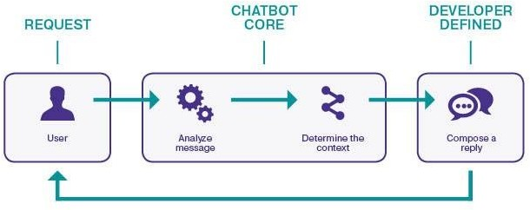

# Problem Statement: Many people now-a-days avoid contacting with real estate brokers, as they find them little hesitant or else too much noisy. Through Real Estate Chatbot now it will be possible for users to clear their doubts and later consult with real estate broke after getting an idea of how to proceed.

# OUTPUT:

We have used site called app.chatbot.com in order to make our real state chatbot. Below image shows the chatbot main screen after user login.

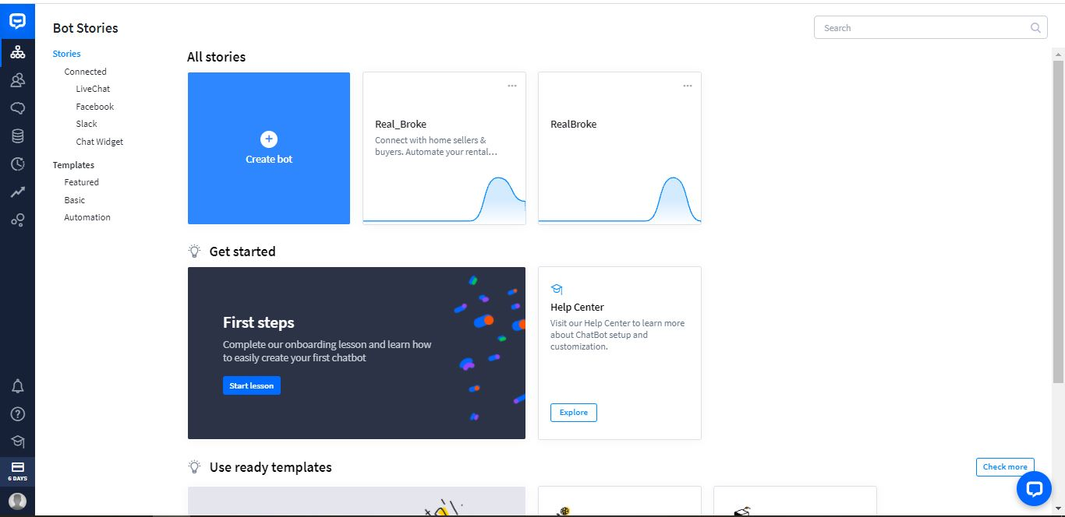

Once all done with login, we can start building our own chatbot in this site we can work on flowchart to proceed with user and bot response.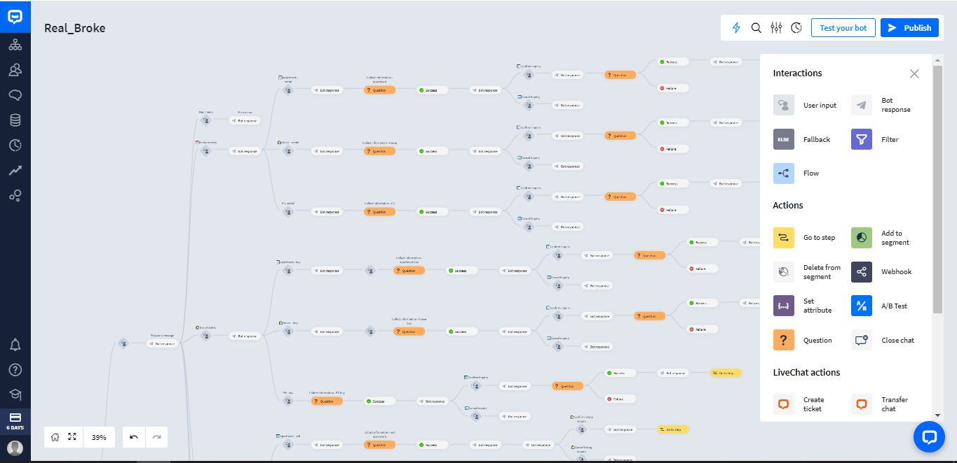

After deploying whole model, we can finally have a chat with chatbot. Below are the images of chatbot.

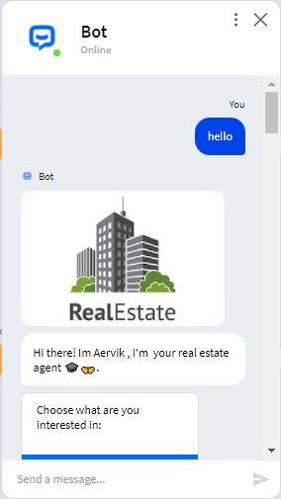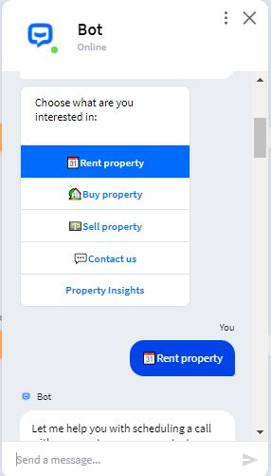

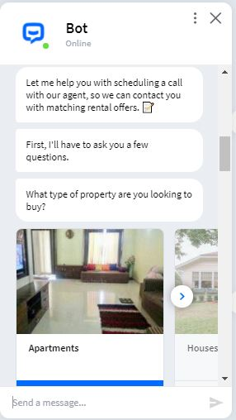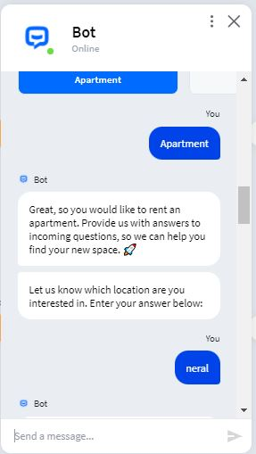

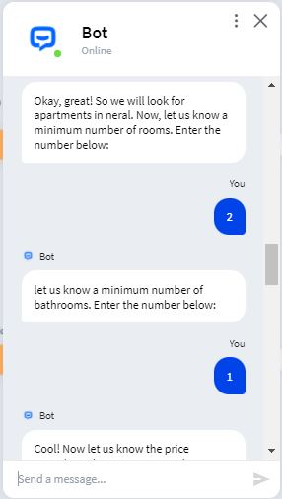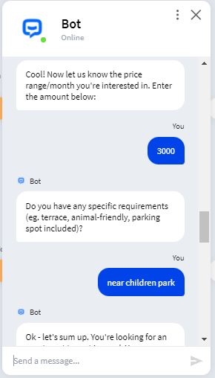

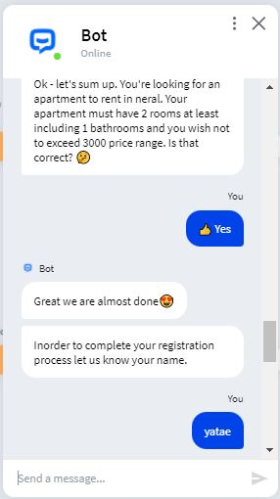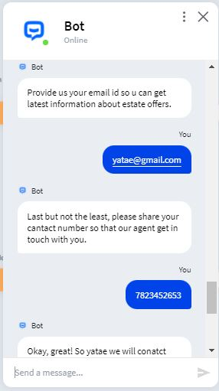

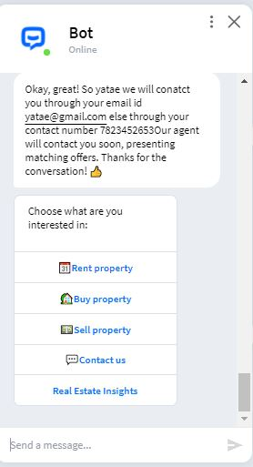

Here is the screenshot of chat between user and bot

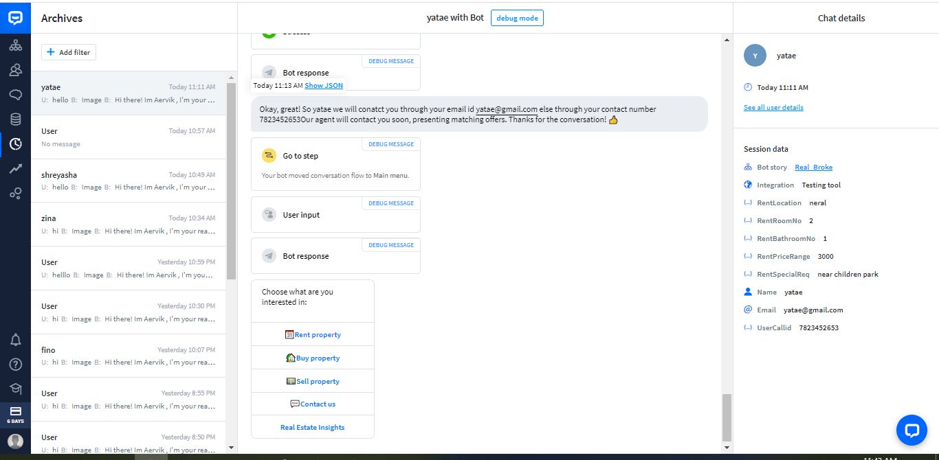

The owner of chatbot can take a look into user’s details whom chatbot has connected to.

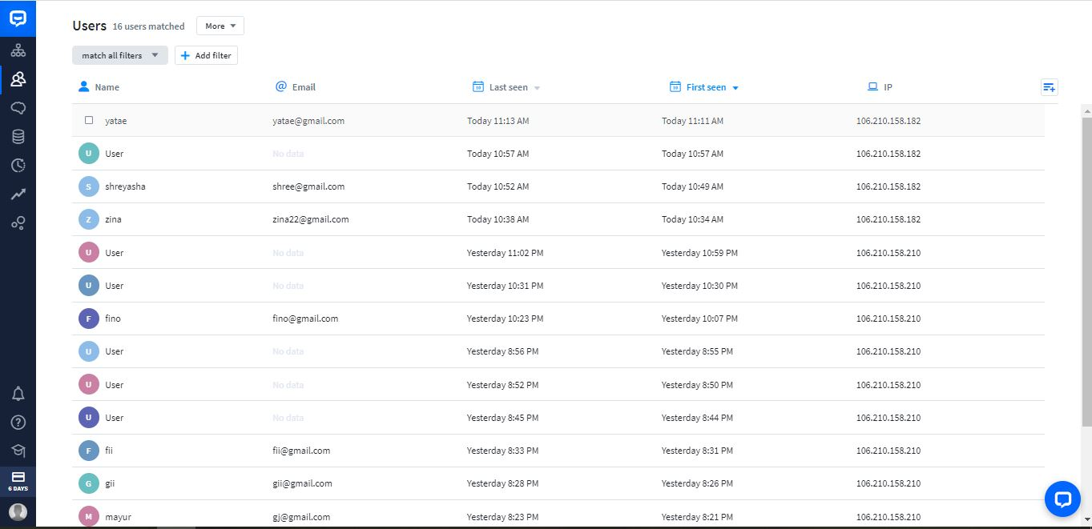

**CONCLUSION:** The usage of Chatbot is user friendly and can be used by anyone who knows how to type in his or her own language in mobile app or desktop version. it answers general questions how to get rid of particular problem and how to treat it. By asking the questions in series, it helps patients by guiding what exactly he/she is looking for.